Intracerebral Hemorrhage Evacuation under MRI: Concentric Tube Robot and Sheep Animal Study

A.L. Gunderman¹, S. Sengupta², J. Sommer¹, D. Sigounas³, K. Cleary⁴, Y. Chen¹

¹Biomedical Engineering Department, Georgia Institute of Technology,

²Institute of Imaging Science, Vanderbilt University Medical Center
³George Washington University

⁴Children’s National Hospital
agunderman3@gatech.edu

Aims: The goal of this project is to develop an MRI-conditional robot to enable intracerebral hemorrhage evacuation within the bore of the magnet. We have developed a low-profile concentric tube robot (CTR) with a central tube of 6 mm diameter to suck out the clot after placement under MRI imaging. Stroke is the second leading cause of death worldwide, causing over six million deaths in 2019 [1]. Intracerebral hemorrhage (ICH), a subcategory of hemorrhagic strokes, accounts for 20% of total stroke deaths, with a one year mortality rate as high as 65% [2]. Minimally invasive methods are impeded by lack of sufficient visualization, which is necessary to account for brain shift and deformation during the evacuation procedure.

Materials and Methods: Our robotic system is a frameless stereotactic CTR that consists of three modular components (Fig. 1): (1) a three degree of freedom concentric tube module (CTM), (2) a pneumatic transmission module (PTM), and (3) a custom designed stereotactic frame (SF). The three degree of freedom CTM utilizes a one degree of freedom outer tube stage (translation) and a two degree of freedom inner tube stage (translation and rotation). The CTM is made entirely of plastic (nylon concentric tubes, nylon lead screws, IGUS bearings, and polylactic acid chassis) and carbon fiber (linear guide rails), eliminating MR-imaging distortion. These motors are driven by 10-meter pneumatic lines routed through the MRI waveguide, allowing the compressor and air distribution components to stay outside the scanner room [3].
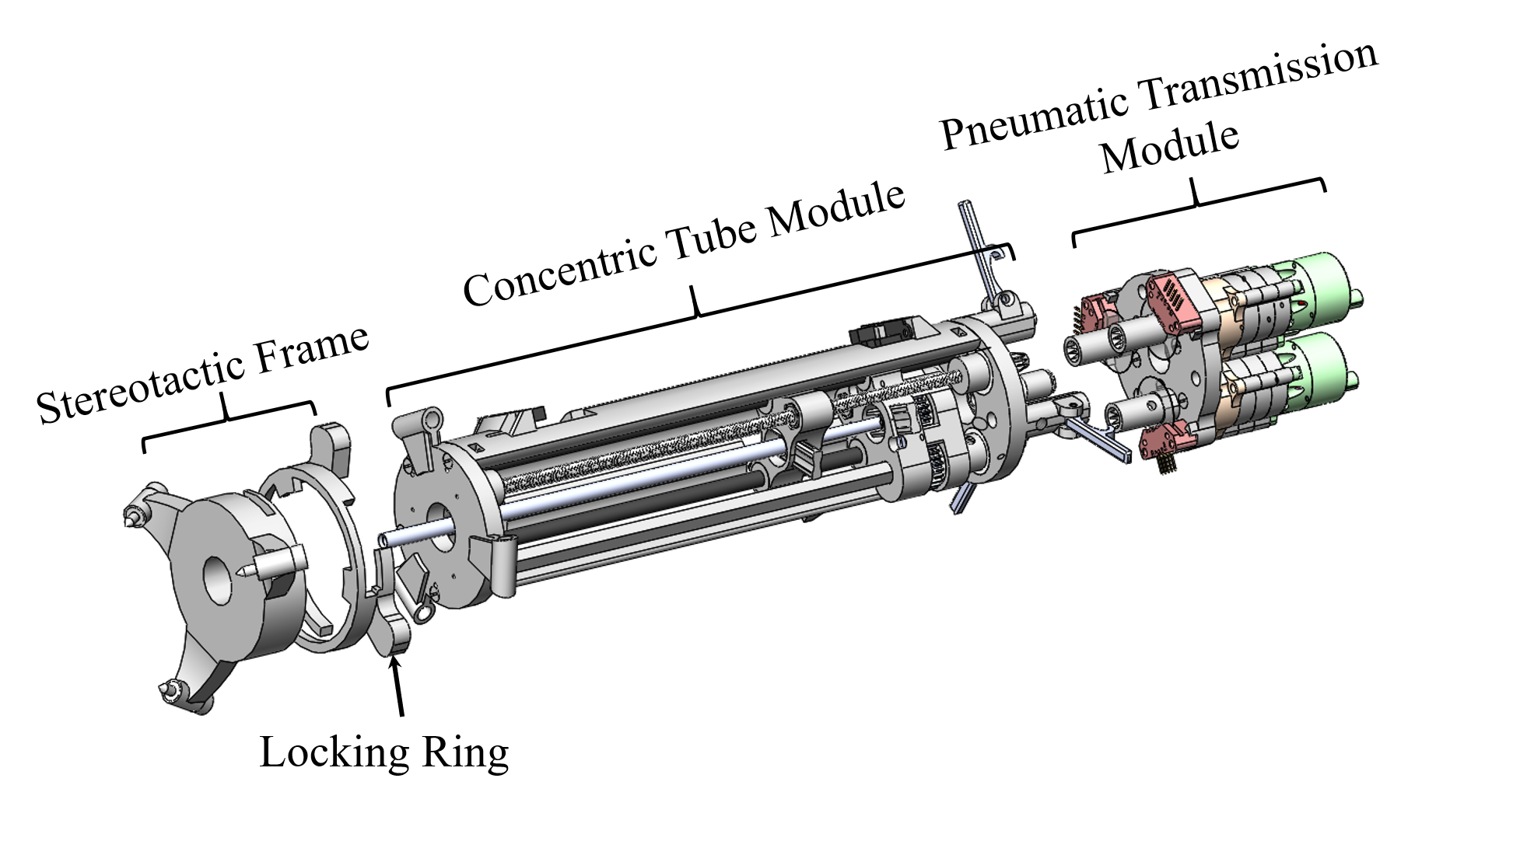
Fig. 1 MRI-compatible ICH concentric tube robot deconstructed into its three separate modules.

Results: After successful tests on phantoms and ex-vivo sheep heads, we completed the first in-vivo MRI-guided sheep animal study under an approved IACUC protocol at the Vanderbilt University Medical Center. The sheep was prepped in an animal care suite and then moved to the animal operating room. The desired location for the stereotactic frame was identified by a neurosurgeon (DS) using fluoroscopic imaging. A burr hole was created in the skull, and a hematoma was created. The animal was then moved to a 3T Philips whole-body MRI scanner for clot evacuation. The robot was mounted on the stereotactic frame and MR images were used to guide the tip of the robot towards the center the center of the clot. Most of the clot was then successfully removed by suction under continuous MR guidance.

Conclusions: This paper presented the first in-vivo animal study of our concentric tube robot for intracerebral hemorrhage evacuation under MRI. Two more studies are planned to improve the method and demonstrate the feasibility of this approach.

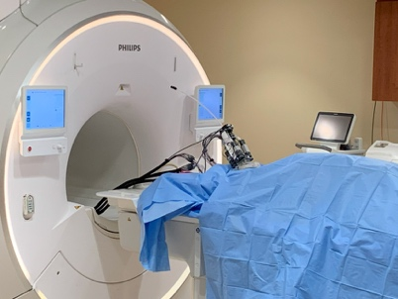
Fig. 2 Robot mounted on frame in MRI scanner with sheep under blue cover.

Acknowledgements: this project was funded by NIH/NINDS under grant R01NS116148. Thanks to Jose Diaz MD and colleagues in the Division of Surgical Research at Vanderbilt for managing the animal study.

References:
[1] Xiong, Ruochu, Fangye Li, and Xiaolei Chen. "Robot-assisted neurosurgery versus conventional treatment for intracerebral hemorrhage: A systematic review and meta-analysis." Journal of Clinical Neuroscience (2020).
[2] Hannah, Theodore C., Rebecca Kellner, and Christopher P. Kellner. "Minimally Invasive Intracerebral Hemorrhage Evacuation Techniques: A Review." Diagnostics 11, no. 3 (2021): 576.
[3] Gunderman, A. L., Sengupta, S., Siampli, E., Sigounas, D., Kellner, C., Oluigbo, C., & Chen, Y. (2023). Non-Metallic MR-Guided Concentric Tube Robot for Intracerebral Hemorrhage Evacuation. IEEE Transactions on Biomedical Engineering. Volume: 70, Issue: 10, October 2023..

